1. How is the shopping distribution according to gender?

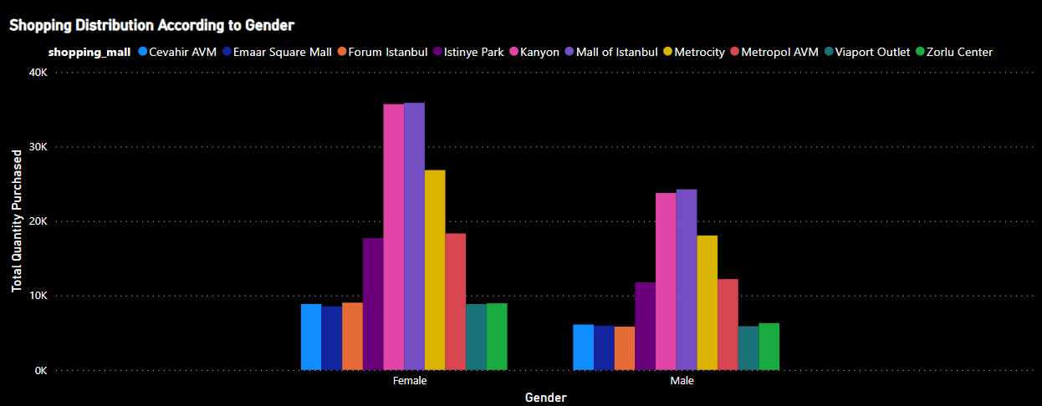

1. Which gender did we sell more products to?

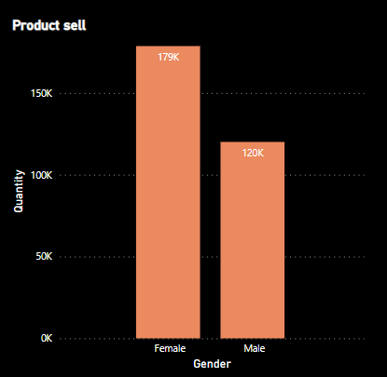

1. Which gender generated more revenue?

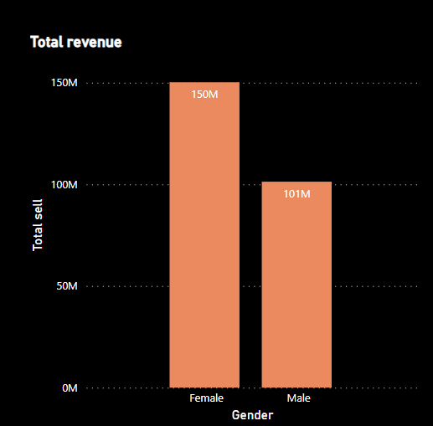

1. Distribution of purchase categories relative to other columns?

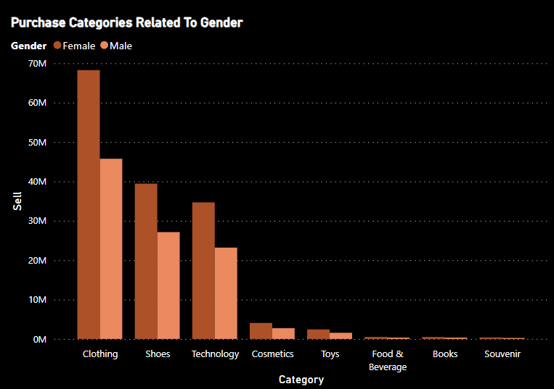

1. How is the shopping distribution according to age?

